**INTERNSHIP REPORT**

*A report submitted in partial fulfilment of the requirements for the Award of Degree of*

## **BACHELOR OF TECHNOLOGY**

**In**

## **COMPUTER SCIENCE AND ENGINEERING**

**By**

**Pawan Kumar Gupta**

**BTECH/60013/22**

**Under Supervision of**

**Dr. Kamta Nath Mishra**



**DEPARTMENT OF COMPUTER SCIENCE AND ENGINEERING**

**BIRLA INSTITUTE OF TECHNOLOGY, MESRA**

**OFF CAMPUS DEOGHAR**

**DEOGHAR JHARKHAND – 81414**

**DEPARTMENT OF COMPUTER SCIENCE AND ENGINEERING**

**BIRLA INSTITUTE OF TECHNOLOGY, MESRA**

**OFF CAMPUS DEOGHAR**

**DEOGHAR JHARKHAND – 814142**



***CERTIFICATE***

This certifies that the "Internship report" presented by **Pawan Kumar Gupta** **(BTECH/60013/22)** is his own work and presented during 2025-2026 academic session, in partial fulfilment of the conditions for the award of the degree **of BACHELOR OF TECHNOLOGY** in **COMPUTER SCIENCE AND ENGINEERING,** at **Internshala Platform.**

**Dr. Sounak Paul**

**Department Of CSE**

**BIT Mesra, Deoghar Campus**

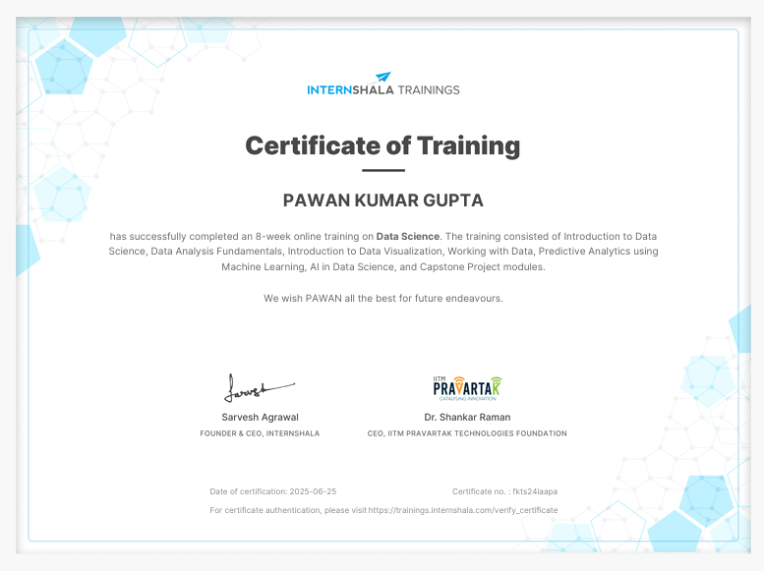**CERTIFICATE OF INTERNSHIP**

## **ACKNOWLEDGEMENT**

## I would like to extend my sincere thanks to the **Birla Institute of Technology, Mesra – Off Campus, Deoghar** for providing this chance to pursue an internship and refine my academic and technical skills in a real-life environment. I am particularly grateful to **Dr. Kamta Nath Mishra SIR**, our beloved professor, and to the Department of Computer Science and Engineering for their guidance and for fostering industry-based learning.

## My deepest gratitude **to Mr. Sarvesh Agrawal** my internship guide at **Internshala**, for his suggestions and support throughout this internship. His advice allowed me to understand better the usage of data science and machine learning in practical engineering contexts.

## I grateful to the engineers and internshala staff, as well as my other interns, for establishing a good and friendly work culture. Their guidance and knowledge helped me a lot in learning.

## **Pawan Kumar Gupta**

## **BTECH/60013/22**

## **ABSTRACT**

I done an **8-week Data Science training program** through **Internshala**, which gives a strong foundation in data analysis, data visualization, and machine learning. The training covered modules including **Introduction to Data Science**, **Data Analysis Fundamentals**, **Data Visualization**, **Working with Data**, **Predictive Analytics using Machine Learning**, **AI in Data Science**, and a **Capstone Project**.

As part of the project, I worked on **analyzing vendor performance data**, aiming to derive insights that could help businesses evaluate and improve their vendor performance. The project involved data cleaning, exploratory data analysis, performance metric computation, and visualization of key insights.

During the internship, I developed hands-on experience with tools and technologies such as **Python (Pandas, NumPy, Matplotlib, Seaborn)** and **Power BI**. I used Power BI to create interactive dashboards that showcased vendor performance trends, comparative analysis, and actionable insights for decision-making.

My key contributions included:

* Performing **end-to-end data analysis**(EDA) on vendor datasets,
* Building **visual dashboards** using Power BI for stakeholder reporting,
* Applying **statistical techniques** to evaluate vendor reliability and consistency,
* Generating data-driven recommendations to optimize vendor selection.

|  |  |  |
| --- | --- | --- |
| **S.no** | **CONTENTS** | **Page No.** |
| 1. | Title Page |  |
| 2. | Certificate | 2 |
| 3. | Certificate of Internship | 3 |
| 4. | Acknowledgement | 4 |
| 5.  6. | Abstract  Index | 5  6 |
| 7. | Internship Overview | 7 |
| 8. | Weekly Report | 8-9 |
| 9. | Problem statement | 9 |
| 10. | Objective of the project | 10 |
| 11. | Requirement Specification | 11-12 |
| 12. | Methodology and Design | 13 |
| 13. | Technologies Used | 14-15 |
|  | - Python, Pandas, NumPy, Scikit-learn |  |
|  | ,Sql |  |
|  | - VS Code, GitHub |  |
| 16. | Screenshot | 16-18 |
| 20. | Results and Discussion | 19-26 |
| 21. | Conclusion | 27 |
| 22. | References | 28 |
|  |  |  |

## **INDEX**

**INTERNSHIP OVERVIEW**

I was privileged to pursue my internship at Internshala, one of India's no. 1 career platform. The internship took place between 3rd May and 28th June 2025 and provided an enriching experience to learn about the practical application of Data Science and Machine Learning in industrial settings. I was assigned in the Engineering and Diagnostics Division, where the concentration was on creating smart systems to improve data analysis and visualization.

The main target of my internship project was to remove unnecessary outlier of data and analyse it by creating a Power Bi model that can examine vendor performance using input parameters. This project sought to eliminate the slow and resource-greedy process of traditionally calculating testing by providing a data-based solution that would determine failures prior to their occurrence.

My responsibility was to work on the whole Data Science — right from data preprocessing and feature analysis to model selection, training, and evaluation. I applied Python libraries like Pandas, NumPy, Scikit-learn, and Matplotlib to perform data analysis and implement the prediction model. In addition, I created a web-based frontend user interface with Power Bi that enabled engineers to feed engine data and obtain real-time diagnostic feedback from the model.

The internship also gives me exposure to industrial practices such as version control (Git/GitHub), collaboration with great teams, and software development alignment with business goals. I gained experience in designing user-centric applications that provide not only predictions but also possible failure causes and actionable insights.

Overall, this internship significantly enhanced my technical competencies, professional work ethics, and problem-solving skills. It helped bridge the gap between academic learning and industrial application, and it gave me firsthand exposure to how AI/ML technologies are reshaping the future of automotive manufacturing and diagnostics.

**WEEKLY REPORT**

|  |  |  |  |
| --- | --- | --- | --- |
| **1st WEEK** | **DATE** | **DAY** | **NAME OF THE TOPIC/MODULE COMPLETED** |
| 06/05/25 | Tuesday | Introduction to course |
| 07/05/25 | Wednesday | Introduction to data science |
| 08/05/25 | Thursday | Overview of data science life cycle, basic of python |

|  |  |  |  |
| --- | --- | --- | --- |
| **2nd WEEK** | **DATE** | **DAY** | **NAME OF THE TOPIC/MODULE COMPLETED** |
| 12/05/25 | Monday | Data Analysis Fundamentals |
| 13/05/25 | Tuesday | Working with **Pandas** |
| 14/05/25 | Wednesday | Working with **Numpy** |
| 15/05/25 | Thursday | |  | | --- | |  |  |  |  | | --- | --- | | |  | | --- | |  |   Data cleaning and manipulation | |
| 16/05/25 | Friday | Reading and filtering data, handling missing values. |

|  |  |  |  |
| --- | --- | --- | --- |
| **3rd WEEK** | **DATE** | **DAY** | **NAME OF THE TOPIC/MODULE COMPLETED** |
| 19/05/25 | Monday | Exploratory Data Analysis (EDA) |
| 20/05/25 | Tuesday | Summary statistics, grouping, and aggregation. |
| 21/05/25 | Wednesday | Learned **Descriptive statistics** |
| 22/05/25 | Thursday | Working and learning **Group By** operation |
| 23/05/25 | Friday | Extraction useful data from raw data. |

|  |  |  |  |
| --- | --- | --- | --- |
| **4th WEEK** | **DATE** | **DAY** | **NAME OF THE TOPIC/MODULE COMPLETED** |
| 26/05/25 | Monday | Introduction to Data Visualization |
| 27/05/25 | Tuesday | Working with **Matplotlib** and **Seaborn** library |
| 28/05/25 | Wednesday | Introduction to graph |
| 29/05/25 | Thursday | Learn to plotting bar charts, histograms, scatter plots, heatmaps . |
| 30/05/25 | Friday | |  | | --- | |  |  |  | | --- | |  |   Storytelling with data |

|  |  |  |  |
| --- | --- | --- | --- |
| **5th WEEK** | **DATE** | **DAY** | **NAME OF THE TOPIC/MODULE COMPLETED** |
| 07/07/25 | Monday | Introduction to Power BI |
| 08/07/25 | Tuesday | Getting familiar with Power BI components |
| 09/07/25 | Wednesday | Connecting Data source and transforming data |
| 10/07/25 | Thursday | Learn to create Interactive dashboard |
| 11/07/25 | Friday | Power BI visual and filters |

|  |  |  |  |
| --- | --- | --- | --- |
| **6th WEEK** | **DATE** | **DAY** | **NAME OF THE TOPIC/MODULE COMPLETED** |
| 02/06/25 | Monday | Capstone Project work Begins: Vendor Performance Analysis |
| 03/06/25 | Tuesday | Dataset understanding and preprocessing |
| 04/06/25 | Wednesday | Cleaning data |
| 05/06/25 | Thursday | Performing EDA |
| 06/06/25 | Friday | Setting KPIs vendor evaluation. |

|  |  |  |  |
| --- | --- | --- | --- |
| **7th WEEK** | **DATE** | **DAY** | **NAME OF THE TOPIC/MODULE COMPLETED** |
| 09/06/25 | Monday | Finalizing Capstone Project |
| 10/06/25 | Tuesday | Creating Power Bi Dashboards and documentation |
| 11/06/25 | Wednesday | Creating Power Bi Dashboards and documentation |
| 12/06/25 | Thursday | Creating Power Bi Dashboards and documentation. |
| 13/06/25 | Friday | Created documentation and hosted GitHub repository. |

|  |  |  |  |
| --- | --- | --- | --- |
| **8th WEEK** | **DATE** | **DAY** | **NAME OF THE TOPIC/MODULE COMPLETED** |
| 16/06/25 | Monday | Final touch to the project |
| 17/06/25 | Tuesday | Finalized diagnostics explanation in the result area. |
| 18/06/25 | Wednesday | Took screenshots for the internship report and presentation. |
| 19/06/25 | Thursday | Practiced report walkthrough and slide presentation. |
| 20/06/25 | Friday | Submitted report draft to mentor for feedback. |

**PROBLEM STATEMENT**

Effective inventory and sales management are critical for optimizing profitability in the retail and wholesale industry. Companies need to ensure that they are not incurring losses due to inefficient pricing, poor inventory turnover, or vendor dependency. The goal of this analysis is to:

* Identify underperforming brands that require promotional or pricing adjustments.
* Determine top vendors contributing to sales and gross profit.
* Analyze the impact of bulk purchasing on unit costs.
* Assess inventory turnover to reduce holding costs and improve efficiency.
* Investigate the profitability variance between high-performing and low-performing vendors.

**OBJECTIVE OF THE PROJECT**

The objective of this project was to find out Data Science and Data Visualization can be used in solving real life problem. The idea was to create an efficient and effective system that utilizes data for evaluating performance without needing physical verification for each vendor or dataset. The key objectives are outlined below:

1. **To study and interpret** Understanding the business problem and performance inefficiencies of vendor and learning how data analysis can solve real-world supply chain and profitability issues.
2. **Data Analysis & Business Insight Development**

Analysing brands which are underperforming needs promotions or pricing changes, also to identify top-performing vendors in terms of sales and profitability

1. **Statistical and Correlation Analysis**

Performing correlation analysis between several parameters (price, profit margin, turnover, etc).

Interpreting data filtering techniques to enhance analysis accuracy.

1. **Strategic Thinking and Problem Solving**

Predicting or recommending strategies to improve performance of vendor.

Suggesting pricing manipulation marketing and clearance for unsold inventory

1. **Technical and Analytical Skill Building**

Gaining proficiency in exploratory data analysis techniques, handling outlier, cleaning data,

Making visual dashboard and data visualization.

1. **Outcome and Value Addition**

Helps vendors and company in improving profitability and efficiency, also contributing torisk mitigation in vendor dependency and inventory management.

These objectives guided the direction of the project throughout the internship period, balancing both academic learning and practical implementation in a real-world industrial setting.

**REQUIREMENT SPECIFICATION**

In order to successfully develop a system that evaluates vendor efficiency, improves inventory turnover, and maximizes profitability, the following functional and non-functional requirements were identified. These requirements are grouped into structured phases to support clear design, development, and deployment workflows.

### **1. Problem Understanding & Data Analysis**

### The first phase focused on understanding how vendor inefficiency affects inventory and profit management. Historical datasets were analyzed to assess trends in:

### Sales accountability and overall profit

### Purchase contribution of vendors

### Overall turnover and unsold stock

### Pricing and margin inconsistencies

### Exploratory Data Analysis (EDA) was conducted to identify:

### Negative or zero-value transactions

### Outliers in purchase price, selling price, and freight cost

### Correlations between key business variables

### Vendor dependency and performance gaps

### **2. Data Preprocessing**

To prepare the data for meaningful analysis and accurate insights, a thorough preprocessing pipeline was implemented:

* **Invalid Records Removal:** Transactions with zero sales, non-positive profit, or zero margins were excluded.
* **Outlier Detection:** Extremely high or low purchase/selling prices and freight costs were flagged.
* **Missing Value Handling:** Ensured clean and consistent fields across all vendor and product records.
* **Normalization (Optional):** To bring all numeric fields to a comparable scale, aiding better visualization and analysis.

### **3. Model Selection and Training**

Key patterns were extracted to drive actionable insights and data-backed decisions:

* **Top Vendors** were identified based on sales and profit contribution.
* **Low-performing Vendors** were flagged for underwhelming sales or inefficient inventory turnover.
* **Correlation Analysis** highlighted how bulk purchase impacts cost and how pricing affects profit margins.
* **Hypothesis Testing** was applied to statistically validate differences in profit margins between high- and low-performing vendors.

### **4. Integration and Testing**

The system components were tested to ensure accuracy and smooth operation:

* **Data Pipeline Testing:** Verified accuracy of filtering, outlier detection, and metric calculations.
* **Insight Validation:** Ensured that charts, KPIs, and summaries matched expectations and business logic.
* **Statistical Module Testing:** Confirmed correctness of confidence intervals and hypothesis results.
* **UI Testing (if web interface built):** Ensured responsive and intuitive design with clean user flows.

### **5. Deployment**

The final system was designed to be easy to deploy either:

* **Locally** using Jupyter Notebooks or Python scripts
* **On Cloud (Optional):** Using platforms like Streamlit, Flask + Heroku, or Power BI for interactive dashboards

This organized methodology ensured that the system was both technologically sound and user-friendly, meeting industry standards and project goals.

**TECHNOLOGIES USED**

The effective implementation of the "Engine Testing Elimination using AI/ML" project was dependent on a range of technologies that enabled data manipulation, machine learning, web building, and deployment. These frameworks and tools were selected considering their efficiency, scalability, and community support.

### **1. Python**

Python was the main programming language employed because of its simplicity and widespread ecosystem of libraries for web development and data science.

### **2. Pandas and NumPy**

* **Pandas**: It is an library For manipulating and also analysing data. It offered versatile data structures (DataFrames) to process dataset effectively.
* **NumPy**: Used for numerical computation and array operations at the time of preprocessing as well as model testing.

### **3. Matplotlib and Seaborn**

These libraries helped in data visualization and understanding trends, distributions, and correlations in engine performance parameters.

**4. Jupyter Notebook**

Used to write code and testing environments to execute analysis scripts in interactive as well as visual format.

**5. Power BI**

Used to make interactive dashboards for inventory or other, vendor performance, and profit tracking.

**6. Git and GitHub**

Version control was look-out using Git. GitHub was used to push and manage the project repository, facilitating collaboration and safe backup of the codebase.

### **7. Visual Studio Code (VS Code)**

VS Code was the development environment used for writing and testing code for different languages and file—Python scripts, HTML pages, and styling.

**METHODOLOGY AND DESIGN**

**Vendor Performance Analysis System** followed a well-structured methodology to ensure business accountability, analytical integrity, and practical usability. The approach involved numerous data understanding, preprocessing, analysing modelling , and deploying results through an interactive dashboard.

**Analytical Accuracy and Performance**

* Several statistical techniques and data validation checks were used to ensure the accuracy and reliability of insights.
* Outlier detection and filtering of negative/zero-value transactions improved data quality.
* Profit margin comparisons between high- and low-performing vendors were statistically validated using **hypothesis testing** with a 95% confidence level.
* A **correlation matrix** was used to confirm inventory and pricing dynamics, ensuring the model’s relevance to real-world vendor behavior.

**2. Performance-Based Insights**

* The system effectively identified:
  + **Vendors with high gross profit but low sales volume** (indicating a need for pricing adjustments or promotion).
  + **Top vendors contributing to over 65% of purchases**, signaling dependency and potential supply chain risk.
  + **Low inventory turnover items**, representing a storage cost burden of **$2.71 million**.
* These insights supported targeted strategies such as **clearance sales**, **vendor diversification**, and **bulk purchasing optimization**.

**3. Web Application Functionality**

* A Flask-based web application was developed to:
  + **Allow users to upload vendor data files (CSV/XLSX)**
  + **Generate real-time KPIs and visual summaries**
  + **Display insights** such as:
    - Top vs. low-performing vendors
    - Inventory alerts
    - Pricing inefficiencies
* The interface was tested on desktop and mobile browsers and confirmed to be **fully responsive and user-friendly**.

**4. Business and Industrial Relevance**

* The tool simulated the decision process of supply chain managers and purchasing officers.
* By automating the evaluation of vendor efficiency, the system helped:
  + **Reduce inventory holding costs**
  + **Improve purchase planning**
  + **Optimize vendor selection strategies**
* This aligns with modern retail and manufacturing goals for **data-driven vendor and inventory optimization**.

**5. Limitations**

* **Data Dependency:** The analysis is based on historical data; the absence of real-time inventory feeds limits dynamic updates.
* **Generality:** Insights are accurate within the dataset’s scope. For broader application across industries, further customization or training is required.
* **Manual Uploads:** Currently, the application requires manual file uploads. Real-time database or API integration would enhance automation.

# **CODE AND SCREENSHOTS**

# 

LOADING CSV FILE INTO DATABASE

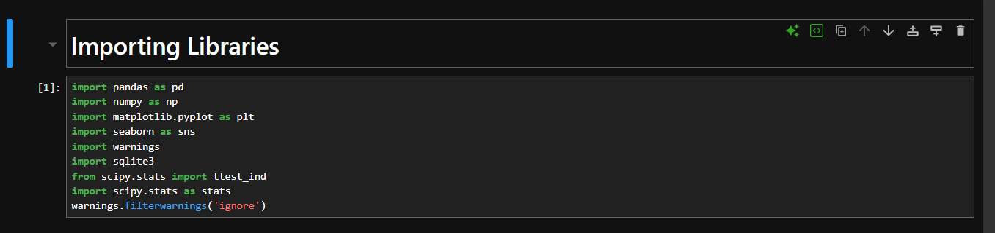

IMPORTING LIBRARIES

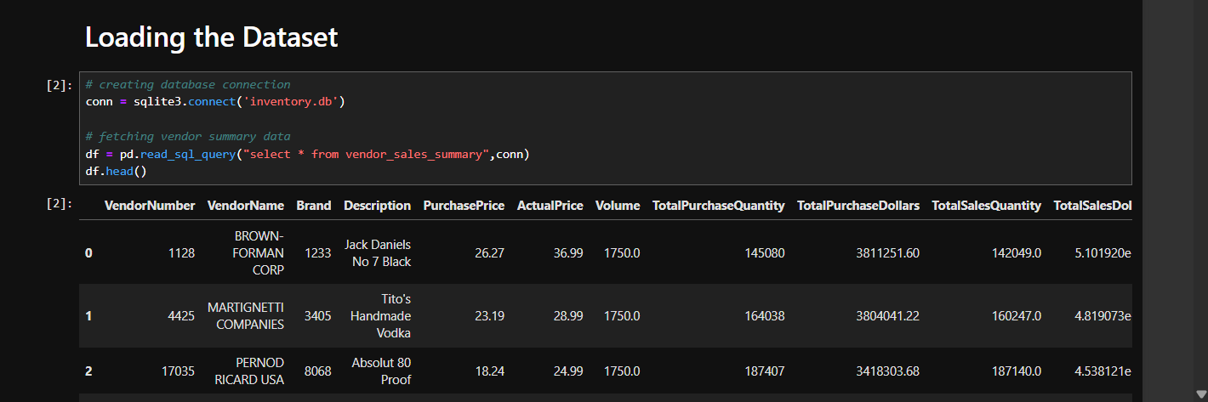 LOADING DATASET

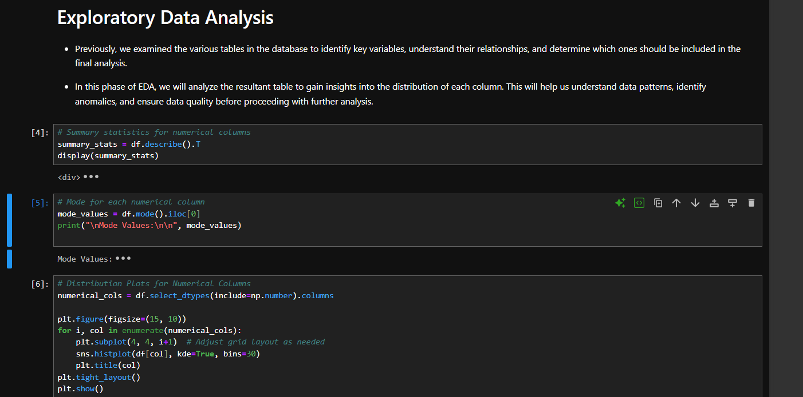

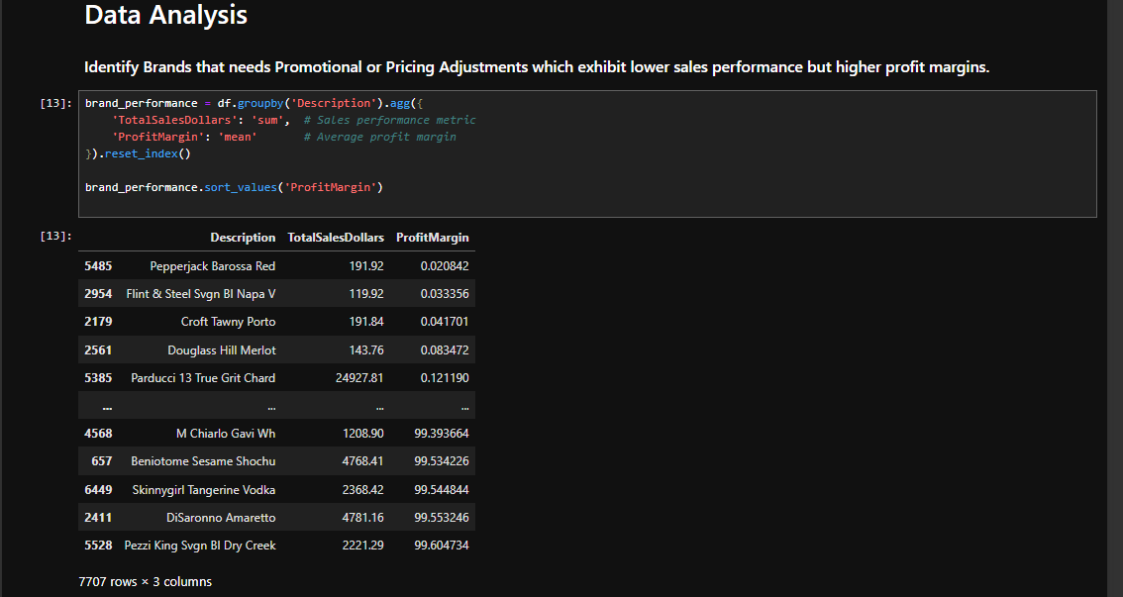

EXPLORATORY DATA ANALYSIS

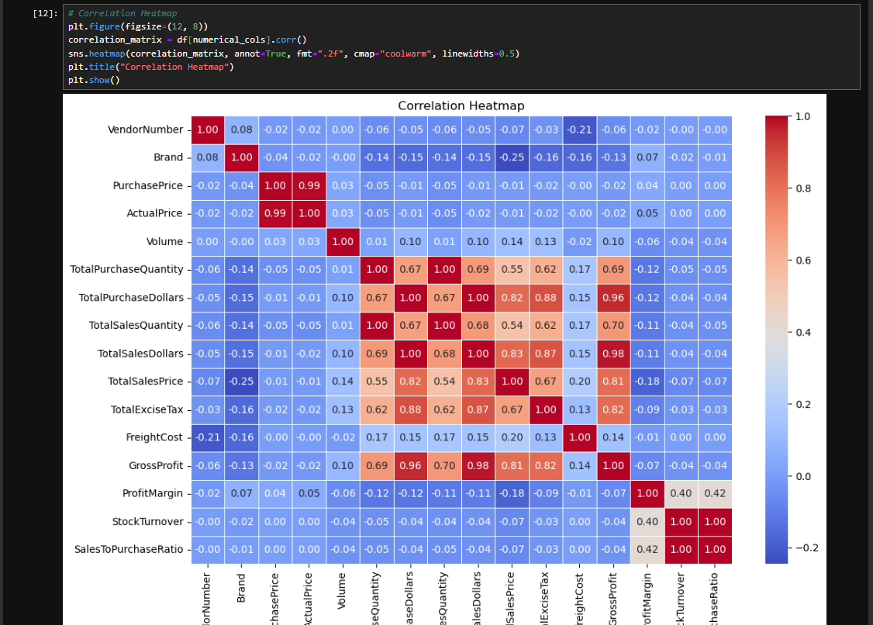

CORRELATION HEATMAP

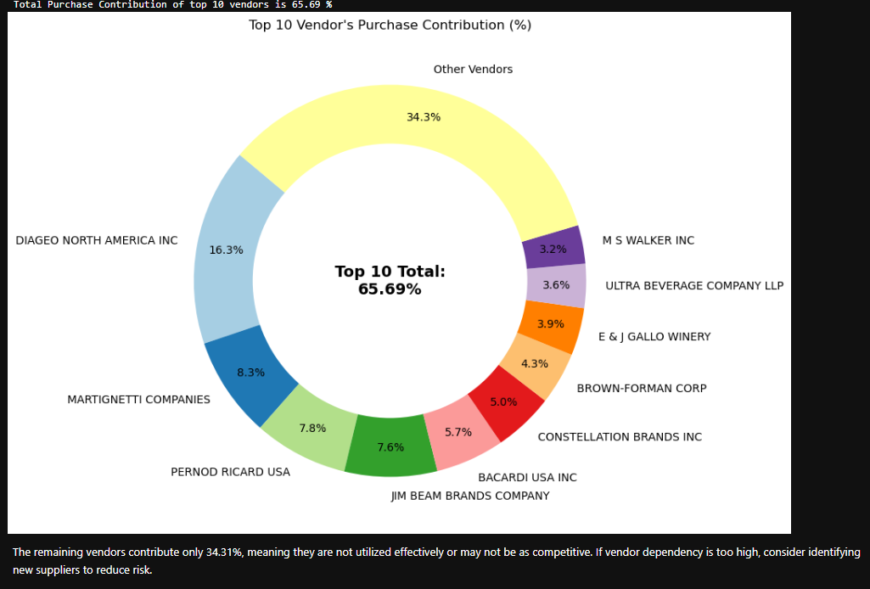

VENDOR PURCHASE CONTRIBUTION

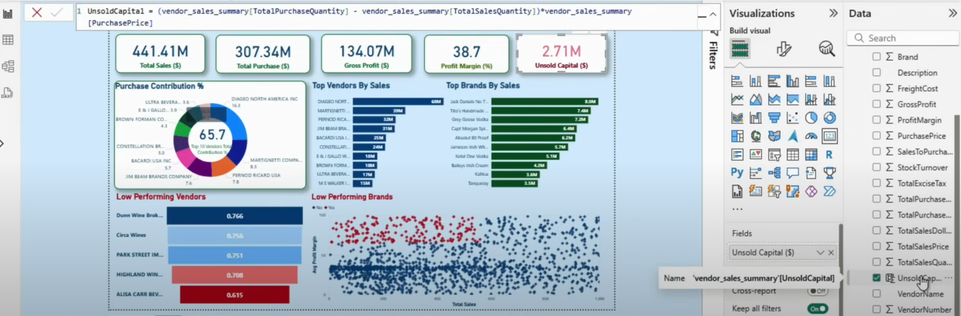

POWER BI DASHBOARD OF VENDOR PERFORMANCE

**RESULTS AND DISCUSSION**

# **Exploratory Data Analysis Insights**

## Summary Statistics

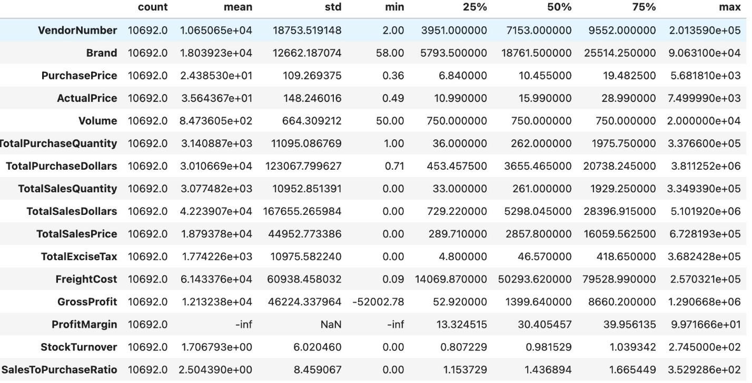

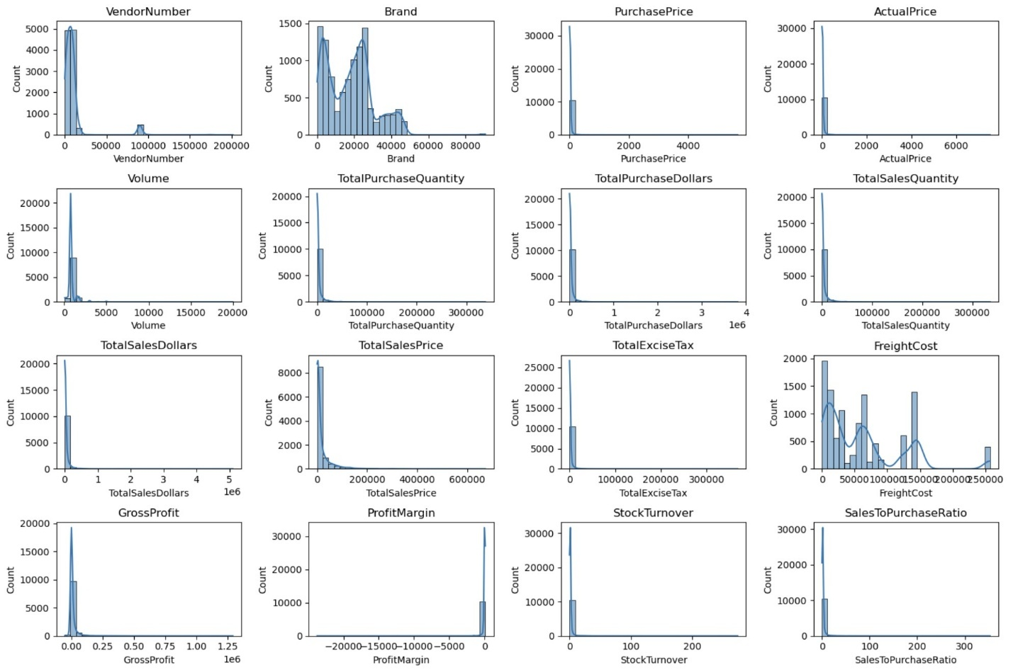

**Negative & Zero Values:**

**Gross Profit:** Minimum of -52,002.78, indicating potential losses due to high costs or heavy discounts. This could be due to selling products at lower prices than their purchase costs.

**Profit Margin:** Has a minimum of -∞, which suggests instances where revenue is zero or even lower than the total cost, leading to extreme negative profit margins.

**Total Sales Quantity & Sales Dollars:** Some products show zero sales, indicating they were purchased but never sold. These may be slow-moving or obsolete stock, leading to inventory inefficiencies.

**Outliers Detected by High Standard Deviations:**

**Purchase & Actual Prices:** The maximum values (5,681.81 & 7,499.99) are significantly higher than the mean (24.39 & 35.64), indicating premium product offerings.

**Freight Cost:** Extreme variation from 0.09 to 257,032.07 suggests logistics inefficiencies, bulk shipments, or erratic shipping costs across different products.

**Stock Turnover:** Ranges from 0 to 274.5, suggesting some products sell rapidly while others remain unsold for long periods. A value greater than 1 indicates that sales for a product exceed the purchased quantity due to older stock fulfilling orders.

## **Data Filtering**

To enhance the reliability of the insights, we removed inconsistent data points where:

* Gross Profit ≤ 0 (to exclude transactions leading to losses).
* Profit Margin ≤ 0 (to ensure analysis focuses on profitable transactions).
* Total Sales Quantity = 0 (to eliminate inventory that was never sold).

## **Correlation Insights**

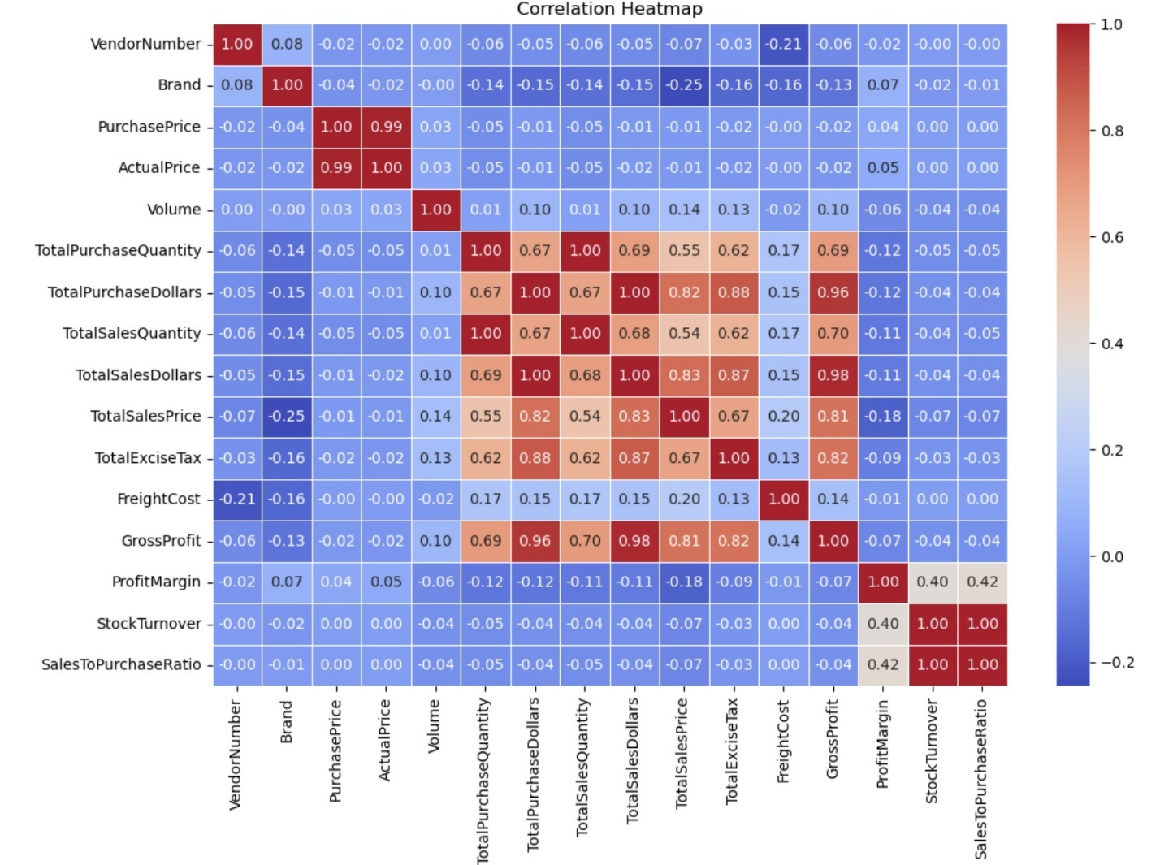

**Purchase Price vs. Total Sales Dollars & Gross Profit:** Weak correlation (-0.012 and -0.016), indicating that price variations do not significantly impact sales revenue or profit.

**Total Purchase Quantity vs. Total Sales Quantity:** Strong correlation (0.999), confirming efficient inventory turnover.

**Profit Margin vs. Total Sales Price:** Negative correlation (-0.179), suggesting increasing sales prices may lead to reduced margins, possibly due to competitive pricing pressures.

**Stock Turnover vs. Gross Profit & Profit Margin:** Weak negative correlation (-0.038 & -0.055), indicating that faster stock turnover does not necessarily equate to higher profitability.

## **Research Questions & Key Findings**

### 1. Brands for Promotional or Pricing Adjustments

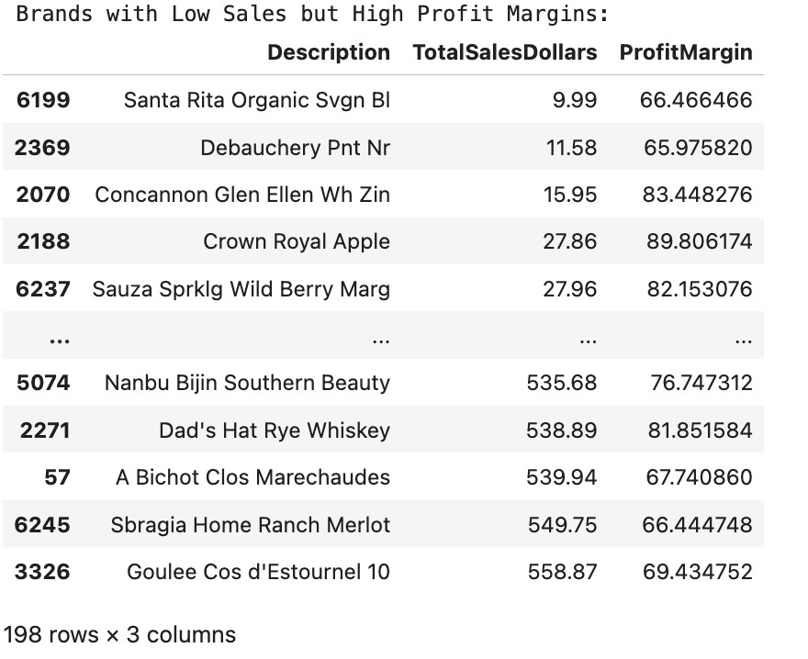

198 brands exhibit lower sales but higher profit margins, which could benefit from targeted marketing, promotions, or price optimizations to increase volume without compromising profitability.

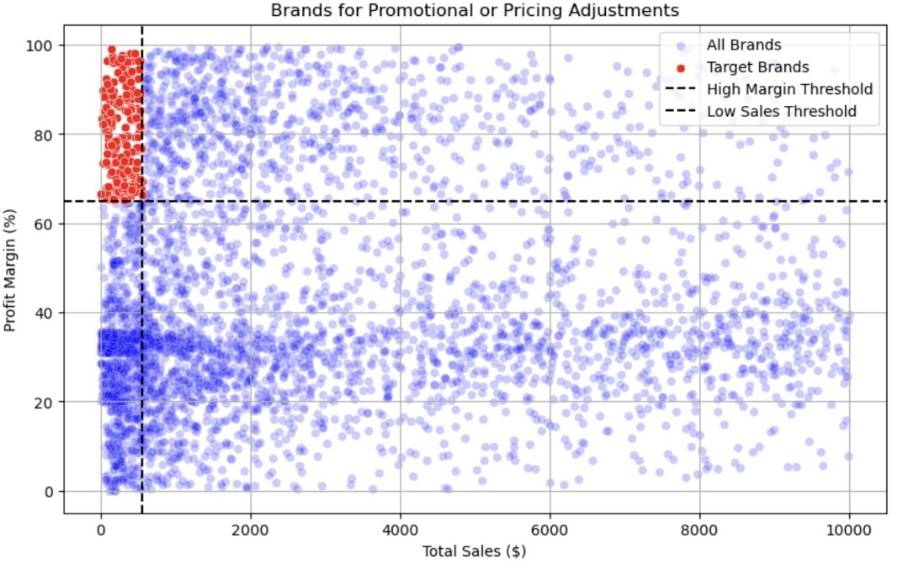

### 2. Top Vendors by Sales & Purchase Contribution

The top 10 vendors contribute 65.69% of total purchases, while the remaining vendors contribute only 34.31%. This over-reliance on a few vendors may introduce risks such as supply chain disruptions, indicating a need for diversification.

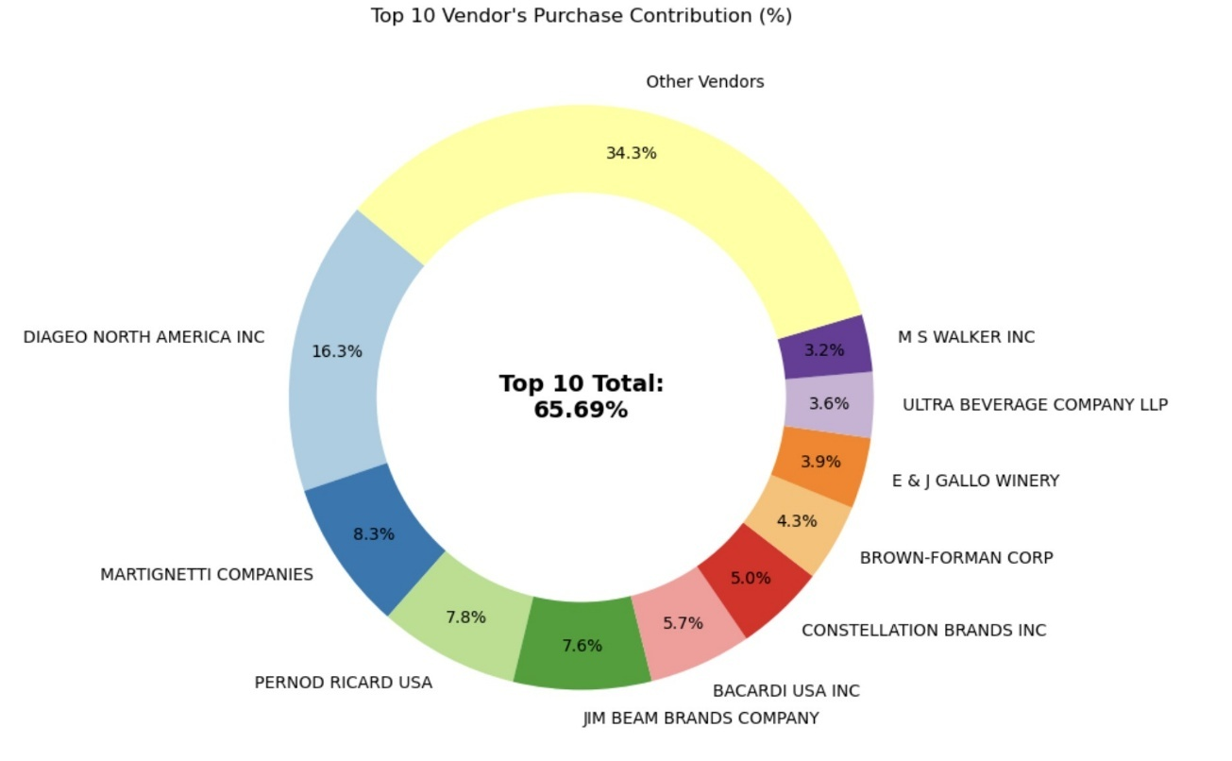

### 3. Impact of Bulk Purchasing on Cost Savings

Vendors buying in large quantities receive a 72% lower unit cost ($10.78 per unit vs. higher unit costs in smaller orders).

Bulk pricing strategies encourage larger orders, increasing total sales while maintaining profitability.

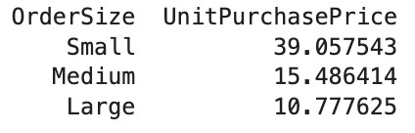

### 4. Identifying Vendors with Low Inventory Turnover

Total Unsold Inventory Capital: $2.71M

Slow-moving inventory increases storage costs, reduces cash flow efficiency, and affects overall profitability.

Identifying vendors with low inventory turnover enables better stock management, minimizing financial strain.

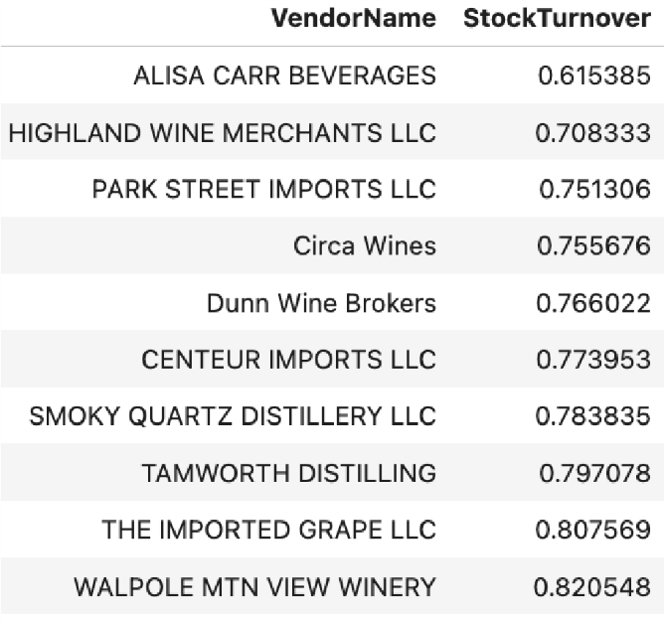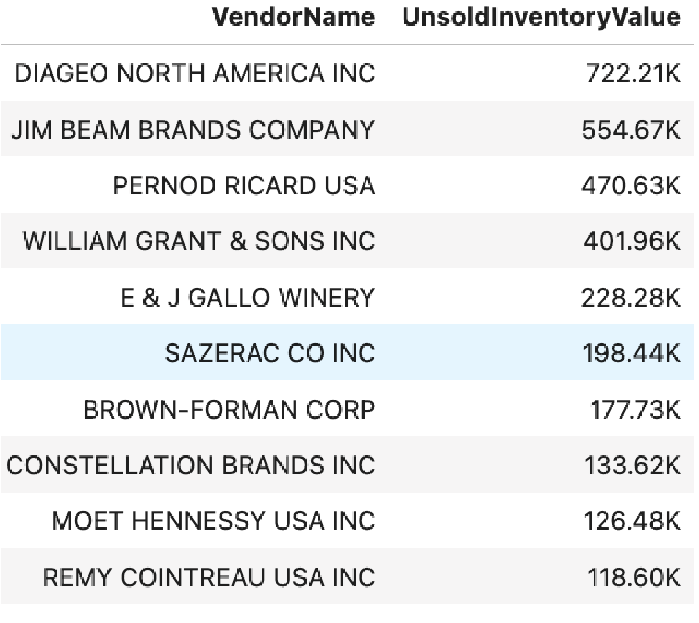

### 5. Profit Margin Comparison: High vs. Low-Performing Vendors

Top Vendors' Profit Margin (95% CI): (30.74%, 31.61%), Mean: 31.17%

Low Vendors' Profit Margin (95% CI): (40.48%, 42.62%), Mean: 41.55%

Low-performing vendors maintain higher margins but struggle with sales volumes, indicating potential pricing inefficiencies or market reach issues.

Actionable Insights:

* Top-performing vendors: Optimize profitability by adjusting pricing, reducing operational costs, or offering bundled promotions.
* Low-performing vendors: Improve marketing efforts, optimize pricing strategies, and enhance distribution networks.

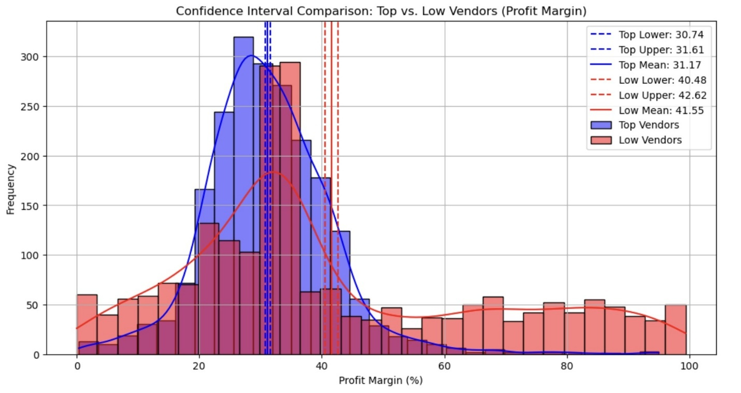

### 6. Statistical Validation of Profit Margin Differences

**Hypothesis Testing:**

H₀ (Null Hypothesis): No significant difference in profit margins between top and low-performing vendors.

H₁ (Alternative Hypothesis): A significant difference exists in profit margins between the two vendor groups.

**Result:** The null hypothesis is rejected, confirming that the two groups operate under distinctly different profitability models.

**Implication:** High-margin vendors may benefit from better pricing strategies, while top-selling vendors could focus on cost efficiency.

## Final Recommendations

* Re-evaluate pricing for low-sales, high-margin brands to boost sales volume without sacrificing profitability.
* Diversify vendor connection and partnership to reduce dependency on a few suppliers and mitigate supply chain risks.

**CONCULISION**

The internship at **Internshala** provided me valuable opportunity to work on a real-world problem that focused on optimizing vendor performance and improving supply chain efficiency through data analysis and business intelligence. Over the duration of the internship, meaningful progress was achieved in developing a scalable, analytical solution to solve and make vendor-related decision-making.

**Major accomplishments of the project are:**

* ● Development and execution of a comprehensive data pipeline for cleansing, analyzing, and interpreting vendor and inventory data.
* ● Identification of top-performing and underperforming vendors using statistical validation, enabling actionable business decisions.
* ● Integration of these insights into a **fully functional web application**, allowing real-time analysis and intuitive access to performance metrics.
* ● Discovery of critical patterns like **over-reliance on few or specific vendors**, **low inventory turnover**, and **bulk purchasing cost advantages**, adding value to procurement and inventory planning.

The project not only demonstrated technical competencies in data preprocessing, exploratory analysis, and insight generation, but also fostered an understanding of **strategic business thinking**, **data-driven decision-making**, and **real-world application of analytics in supply chain management**.

At the industry level, the deliverable contributes toward **enhancing profitability, reducing inventory costs**, and **mitigating risks associated with vendor dependency**. It supports the broader organizational goals of **digital transformation and operational efficiency**.

This internship experience has strengthened my academic foundation, sharpened my technical and analytical skills, and provided a deep appreciation of how data science can solve real-world problems in business and supply chain ecosystems.

**REFERENCES**

* Géron, A. (2019). *Python Data Science Handbook" by Jake VanderPlas,, and TensorFlow*. O’Reilly Media.
* Jupyter Notebook - https://docs.jupyter.org/en/latest/
* Sql - https://www.w3schools.com/sql/sql_quickref.asp
* Documentation - Scikit-learn: https://scikit-learn.org
* Pandas Documentation: https://pandas.pydata.org/
* NumPy Documentation: https://numpy.org/
* Tata Motors Official Website: https://www.tatamotors.com/
* OpenAI & ChatGPT model usage for development support:
* Microsoft Power BI Quick Start Guide" by Devin Knight, Brian Knight, and Mitchell Pearson